

Michael Ricketts, 000306935 |Mohawk College| Technical Writing | April 15, 2018 | Section 5

Technical Report

Corel WordPerfect or Microsoft Word

Table of Contents

Introduction page 1

Executive Summary page 1

Discussion page 2

• Compatibility page 2

• Convenience page 2

* Margin Adjustment………………………………………………………………………………………………………page 2
* Cursor Placement…………………………………………………………………………………………………………page 3
* Tabs……………………………………………………………………………………………………………………………..page 3
* Mailings……………………………………………………………………………………………………………………….page 3

• User Interface……………………………………………………………………………………………………………………page 4

* Icons……………………………………………………………………………………………………………………………page 4

• System Requirements page 5

* Central Processing Unit………………………………………………………………………………………………..page 5
* Graphics Processing Unit……………………………………………………………………………………………..page 5
* RAAM……………………………………………………………………………………………………………………………page 5
* Hard Drive Memory……………………………………………………………………………………………………..page 5

Conclusion page 5

References page 6

# Introduction

The purpose of this report is to compare two desktop productivity applications: Microsoft Word 2016 and Corel WordPerfect X8. These two applications are utilized primarily for word processing and can prove very convenient in a workplace setting. Both programs can produce documents such as reports, in a well formatted manner; suitable for the company’s needs. The software will be compared through their ease of use and functionality, and a recommendation will then be given.

# Executive Summary

The purpose of this report was to compare two desktop productivity applications: Microsoft Word 2016 and Corel WordPerfect X8. These two applications are utilized primarily for word processing and can prove very convenient in a workplace setting. The software was compared through their ease of use and functionality

The compatibility of these two programs were contrasted firstly. It was found that Microsoft Word maintains a large percent of the market and is used by the majority of businesses and schools. Thereby, making this software the most likely to be compatible with the company’s recipients; minimizing any formatting issues.

When analyzing the convenience factor between the two, it was found that WordPerfect does have many unique features that cannot be found in Word. For instance, WordPerfect allows the user to adjust margins without entering into a menu system. It also allows the user to begin typing anywhere on the page, by simply clicking a location. However, these convenience features were not found to be as imperative as the compatibility of Word.

The user interfaces were also analyzed, and this facet favored Microsoft Word. Corel WordPerfect implements a somewhat old-fashioned design, whereas Word implements a modernized user-interface. The icons on Word are displayed in a larger size and the layout design is colorized, giving it a more modern aesthetic.

Lastly, the system requirements were analyzed. It was found that both programs require 1GHz of processing power, and 1 GB of RAAM. The only differentiating factor was the amount of hard drive space demanded. Corel WordPerfect requires 1.5GB of space and Microsoft Word requires 3GB.

In conclusion, Microsoft Word 2016 is the recommended adoption choice. Both applications offer features valuable to a business setting. However due to the compatibility, user interface, and convenience of Microsoft Word, it is the recommendation for implementation.

# Discussion

# Compatibility

Due to Microsoft Word being included in the Microsoft Windows ecosystem, Word has garnered much more popularity than WordPerfect among the masses. Word firmly maintains 90% of the market and has become the standard among most schools and businesses. Therefore, most recipients of a document will likely be opening them with Word. Therefore, formatting files using Corel WordPerfect could become an issue if the file is not compatible with Word. This region, is where WordPerfect falters most.

# Convenience

* Margin Adjustment

Inside Corel WordPerfect, adjusting page margins is a simple and intuitive process. The page margins are displayed to the user on each side of the page layout; rather than inside a submenu as in Word. They can then be adjusted by simply clicking and dragging to the desired width or length. You can also adjust the margin widths of specific lines on the page this way. Adjusting margins inside of Word is not a hassle but it does require learning the Menu system; as margins are not visible on the page layout by default.

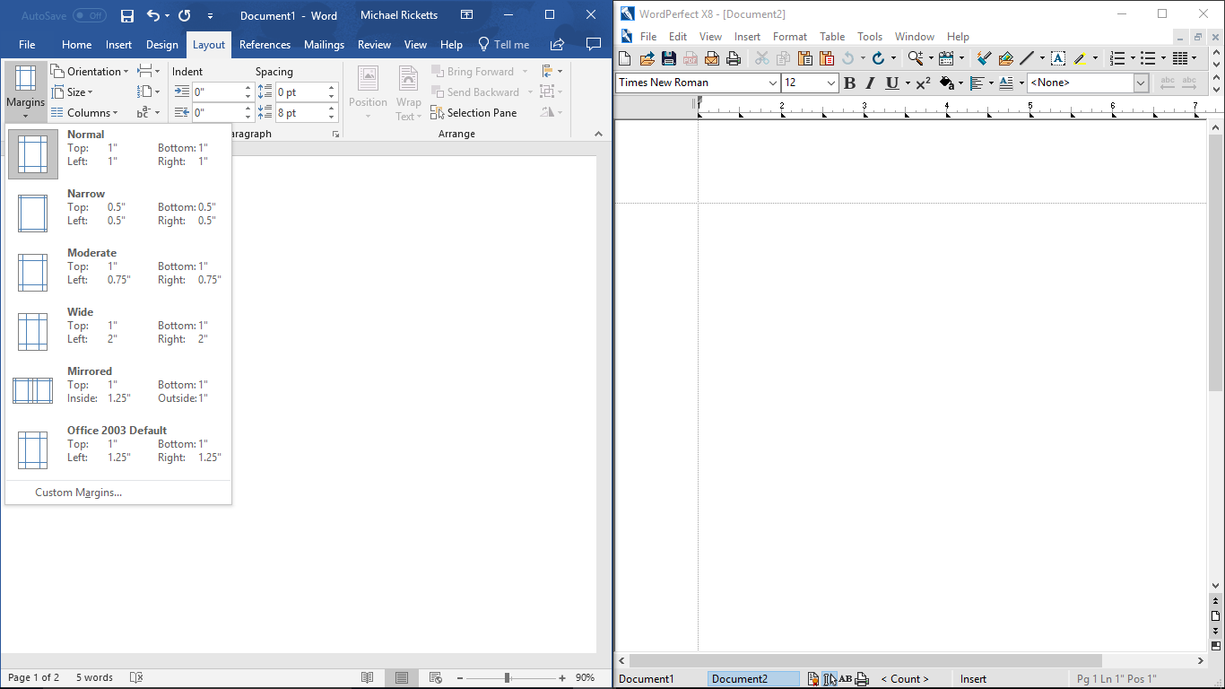

Figure 1: Margin Adjustment

* Cursor Placement

Another convenient feature of WordPerfect is the ability to begin typing anywhere on the page by simply clicking. Conversely Word does not allow users to freely type anywhere on the page as simply. Word places the cursor at the end of the last sentence written or the leftmost region of the page. Therefore, you must continuously press the space bar and enter key to get the cursor to the desired position.

* Tabs

When the user opens multiple documents, the two applications have different responses. Microsoft Word opens an entirely new window, whereas WordPerfect uses only one window and opens the second document under a tab. Corel WordPerfect’s tabs enable the user to switch between files effortlessly and intuitively on one page, resulting in more organization. Contrarily Word can cause a screen to become cluttered, and possibly slow down a machine due to the many open windows.

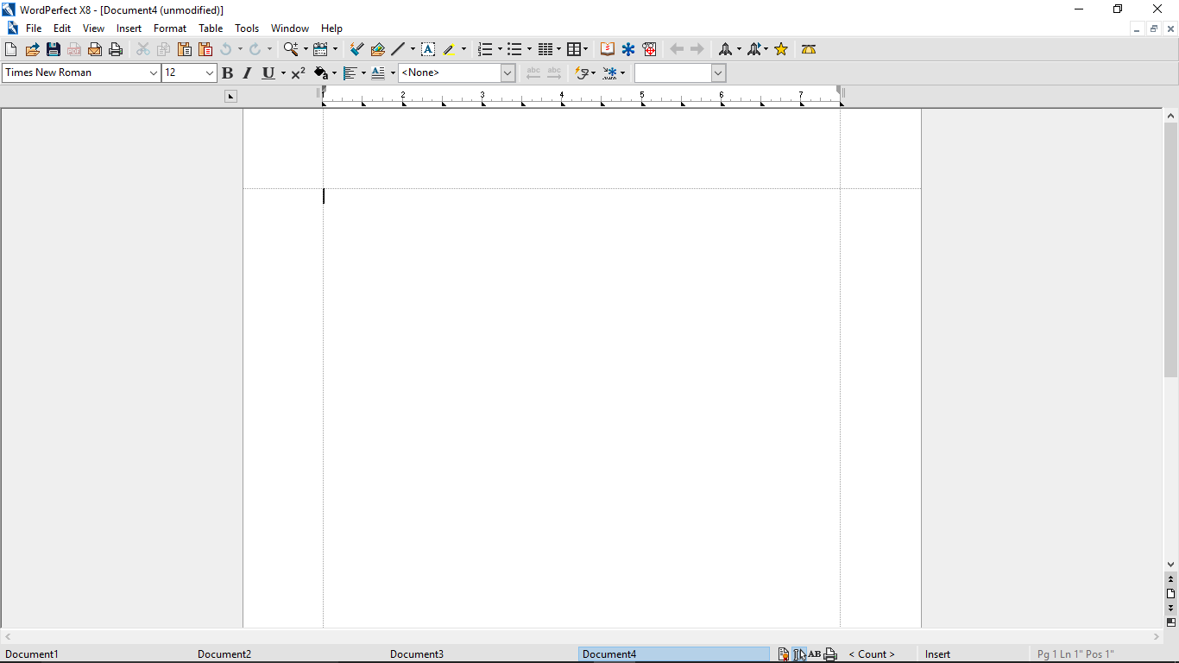Figure 2: Tabs in Corel WordPerfect

* Mailings

Microsoft Word incorporates a convenient feature in the menu system titled ‘Mailings’. Under this menu, the user is able to format the document into an e-mail format as they type. This feature is convenient in a business setting, wherein many e-mails are sent.

# User Interface

The design of the user interface, can greatly impact user experience. A user interface can sometimes be the driving factor between the purchase of one software over the other. A smooth and intuitive design that offers ease of use, can be worth more than feature sets and functionality in some cases. When analyzing this important facet of each of the two programs, it is apparent that Microsoft’s Word has an advantage.

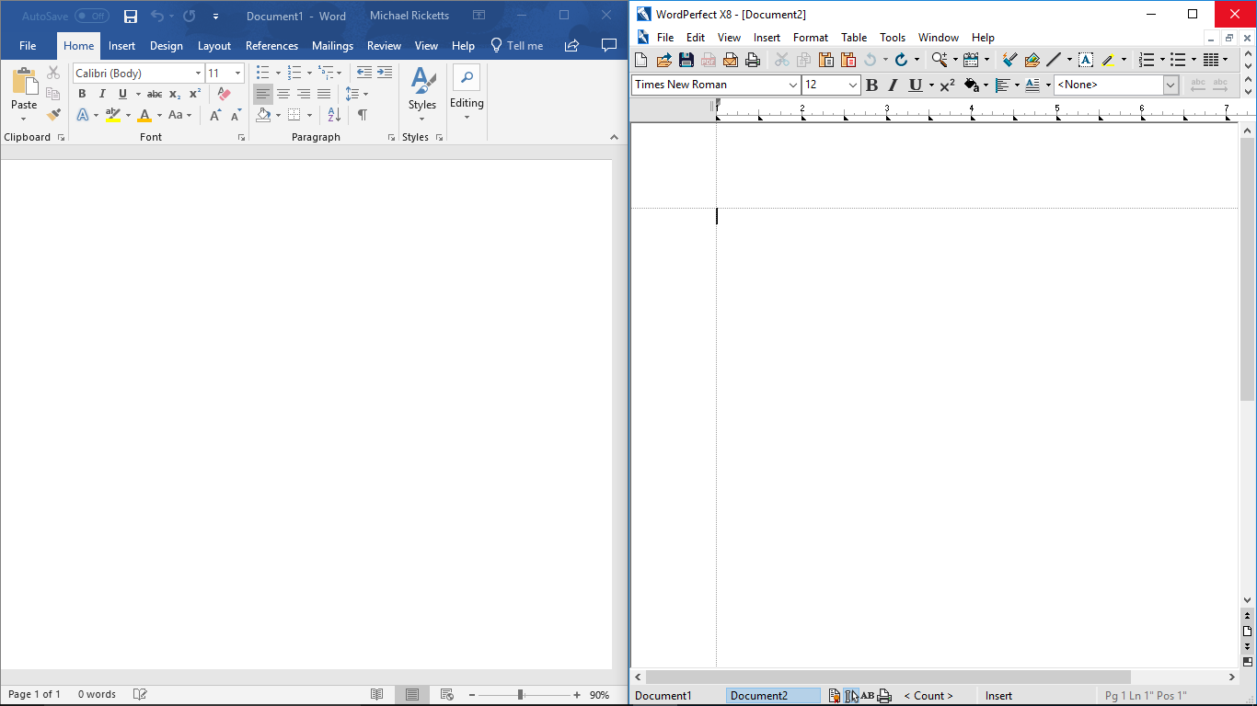

Figure 3: User Interfaces

* Icons

WordPerfect’s icons and layout uses a somewhat old-fashioned design, that heralds back to a 1990’s aesthetic. The colors used are mostly grey and the icons are very simply designed. Whereas Word employs more color into their layout and displays the icons in a larger size. This results in a much more modernized aesthetic.

# System Requirements

A point of consideration when choosing a word processing program over another, would certainly come from its ability to run on your machine. When examining and comparing the requirements, it’s apparent that both programs are very similar in this regard.

* Central Processing Unit

Both Corel WordPerfect and Microsoft Word require an x86-bit or x64-bit processor with 1 gigahertz of processing power.

* Graphics Processing Unit

The GPU required for Microsoft Word is a DirectX 10 graphics card. Whereas no GPU is required for WordPerfect to run.

* RAAM

Corel WordPerfect and Microsoft Word both require a machine with 1GB of RAAM to operate.

* Hard Drive Memory

There is a slight differentiation in this field. The two programs necessitate a machine with slightly different amounts of hard drive space. WordPerfect requires 1.5GB of hard drive space, however Word requires twice that amount with 3GB of hard drive space needed.

# Conclusion

After analyzation of the two programs for the company’s needs, the ideal program was found to be Microsoft Word 2016. When the system requirements were considered, although WordPerfect demands less hard drive space, the minor difference is quite benign unless the software is intended to operate on a device with very limited memory. Otherwise, both programs should run well without any overload to system resources, on any relatively modern system. Through further consideration the user interface was also found to be a superior design in Word. WordPerfect does incorporate quite a few convenient features that are absent in Word, however WordPerfect falters when compatibility is considered. The vast adoption of Microsoft Word throughout the business and academic settings, proved to be a major incentive for compatibility purposes. These results led to the conclusion that Microsoft Word 2016, is the recommended word processing application for the company.

# References

<https://www.cnet.com/products/microsoft-word-2016-media-05909005/specs/>

<https://support.corel.com/hc/en-us/articles/219326427-WordPerfect-Office-X8-Home-Student-Edition-System-Requirements>

<https://www.onmsft.com/news/microsoft-numbers-look-how-many-people-are-using-microsofts-products-and-services>